Antibiotic Resistance (16 marks)
Antibiotic | Zone (mm)
A
B
C
D
E
F
G
The agar in the Petri dish was inoculated with a culture of Streptococcus pyogenes from a patient diagnosed with strep throat. Observe and measure the zones of inhibition created by the 7 antibiotics on the discs placed on the agar in the Petri dish below. (7)
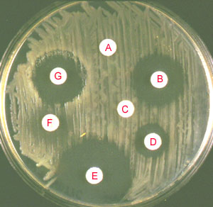

a) Explain, referencing data, which antibiotic would be the BEST to use to treat the patient’s infection?
_______________________________________________________________________________________________________________________________________________________________________________________________________________________________________________________________________________________________________________________________________________________________________________________________________________________________________(3)
b) Does the bacteria seem to show resistance to any of the antibiotics tested? Explain, referencing data.
_______________________________________________________________________________________________________________________________________________________________________________________________________________________________________________________________________________________________________________________________________________________________________________________________________________________________________(3)

c) Suppose you write a prescription to the patient to take your chosen antibiotic for 10 days. Write below what you would say to the patient to explain why it is important to continue taking the antibiotic for the entire 10 days and NOT to stop taking it any sooner.
_________________________________________________________________________________________________________________________________________________________________________________________________________________________________________________________________________________________________________________________________________________________________________________________________________________________________________________________________________________________________________________________________________________________________________________________________________________(3)

