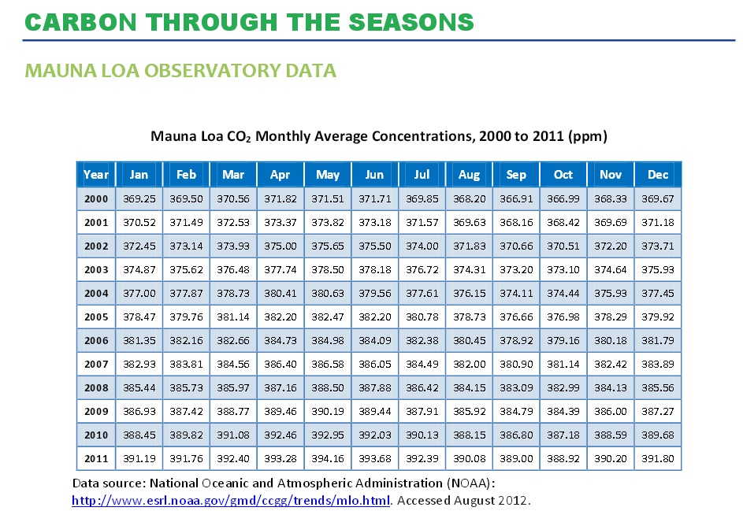

What is/are the reason(s) for the monthly carbon dioxide fluctuations (northern hemisphere)?

