Genetics Review: IB Biology

1. In Zea Mays (corn), colored (C) is dominant to no color (c) and waxy (W) is dominant to not waxy (w). In a cross between a plant that is homozygous dominant at both loci (CW/CW) with a plant that is heterozygous at both loci (CW/cw), which of the following would be genotypes classified as recombinant offspring? (you may choose more than one).
a) CcWw b) CCWw c) CcWW d) CCWW e) CCww f) ccWW

2. In Zea Mays (corn), colored (C) is dominant to no color (c) and waxy (W) is dominant to not waxy (w). In a cross between a plant that is homozygous dominant at both loci (CW/CW) with a plant that is heterozygous at both loci (CW/cw), which of the following would be genotypes classified as regular, non-recombinant offspring? (you may choose more than one).
a) CcWw b) CCWw c) CcWW d) CCWW e) CCww f) ccWW

3. In Zea Mays (corn), colored (C) is dominant to no color (c) and waxy (W) is dominant to not waxy (w). In a cross between a plant that is homozygous dominant at both loci (CW/CW) with a plant that is heterozygous at both loci (CW/cw), which of the following would be genotypes classified as offspring that are not possible from this cross? (you may choose more than one).
a) CcWw b) CCWw c) CcWW d) CCWW e) CCww f) ccWW

4. Two genes are linked as shown here
E a
________
________
e A
The genes are far apart such that crossing-over between the alleles occurs occasionally. Which statement is true of the gametes?
a) All of the gametes will be Ea and eA.
b) There will be more Ea gametes than ea gametes.
c) There will be equal numbers of EA, eA, ea, and Ea.
d) There will be approximately equal numbers of EA and eA gametes.

5. Which description best fits the image? B
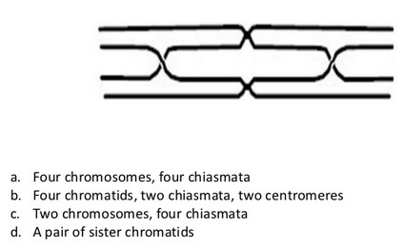

6. Traits that are influenced by at least several genes and also the environment are known as:
a) polygenic b) variations c) dominant d) recessive

7. The genotypes that cannot be determined from the inspection of the offspring of a cross are the:
a) homozygous
b) codominant
c) homozygous dominant and the heterozygous dominant
d) codominant and the homozygous recessive

8. Each parent contributes one of the genes for a particular trait. The genes of the pair are called:
a) alleles b) gametes c) hybrids d) variables

9. Three babies were recently mixed up in a hospital. The blood types of the possible parents are babies are shown below:
Parents 1 | Parents 2 | Parents 3 | Baby 1 | Baby 2 | Baby 3
A and B | A and A | AB and O | B | O | AB

Who are the possible parents of baby 1?
a) Parents 2 b) Parents 1 c) Parents 3

10. A father is heterozygous for a particular autosomal dominant trait. If his spouse is homozygous recessive for the same trait, what percentage of their offspring can be expected to express the dominant condition?
a) 50% b) 0% c) 25% d) 75% e) 100%

11. In snapdragons, tallness (T) is dominant to dwarfness (t), while red flower color is due to gene (R) and white to its allele (r). The heterozygous condition results in pink (Rr) flower color. A dwarf red snapdragon is crossed with a plant homozygous for tallness and white flowers. What percentage of the offspring can be expected to have the tall pink-flowered phenotype.
a) 50% b) 0% c) 25% d) 75% e) 100%

12. The term “sex-linked trait” almost universally refers to alleles with genes on the
a) 22 autosomes b) Y chromosome c) X chromosomes

13. Chromosomes that carry genes that code for the same products, such as hemoglobin or eye pigment, are said to be:
a) homozygous c) heterogeneous
b) homologous d) heterozygous

14. When two bell shaped squash are crossed, 25% of the offspring are round, 25% are oblong, and 50% are in between, or bell shaped. This cross illustrates:
a) multiple alleles c) polygenic inheritance
b) a recessive trait d) codominance

15. In all conditions in which a defective gene is on the X chromosome, transmission to a male can be:
a) only from his father c) only from his mother
b) from neither his mother nor father d) either from his father or mother

16. During which phase of meiosis do bivalents/tetrads/homologous chromosomes separate?
a) Metaphase I b) Metaphase II c) Anaphase I d) Anaphase II

17. The fact that different alleles for different genes are usually on different chromosomes, and segregate independently of each other during meiosis is...
a) The law of segregation.
b) The law of independent assortment.
c) The law of dominance and recessiveness.
d) All of the above.

18. The fact that homologous chromosomes randomly orient (line up) during metaphase I of meiosis, resulting in the equal chance of passing on either allele of a gene is…
a) The law of segregation
b) The law of independent assortment
c) The law of dominance and recessiveness
d) All of the above

19. Polygenic inheritance will exhibit…
a) continuous distribution of phenotypes
b) discontinuous distribution of phenotypes
c) a limited number of phenotypes
d) at most 3 different phenotypes

20. What event occurs in meiosis but not mitosis?
a) Chromosome condensation c) Chromatid separation
b) Crossing over d) Chromosome movement to poles

21. Mitosis results in ___________________; meiosis results in __________________.
a) 2 haploid cells; 2 diploid cells
b) 4 haploid cells; 2 diploid cells
c) 2 diploid cells; 4 haploid cells
d) 4 haploid cells; 4 hapolid cells

22. A cell that is 2N = 24 goes through meiosis. How many chromosomes are in each daughter cell?
a) 24 b) 12 c) 48 d) 6

23. If there are 20 chromatids in a cell, how many centromeres are there?
a) 10 b) 20 c) 30 d) 40

24. In a karyotype, chromosomes are arranged by their…
I. size
II. banding pattern
III. centromere position
a) I only b) II only c) III only d) I and II only d) I, II and III

25. A parent organism of unknown genotype is mated in a test cross. Half of the offspring have the same phenotype as the parent. What can be concluded from this result?
a) The parent is heterozygous for the trait.
b) The trait being inherited is polygenic.
c) The parent is homozygous dominant for the trait.
d) The parent is homozygous recessive for the trait.

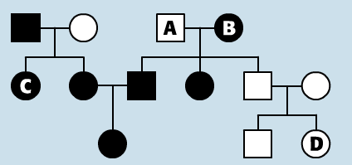
26. At right is a pedigree of dwarfism.
Dwarfs are shown by blackened symbols.
This trait is inherited as…
a) autosomal dominant
b) autosomal recessive
c) codominant
d) sex-linked recessive

27. At right is a pedigree of dwarfism.
What is the genotype of A?

a) Dd c) dd
b) DD e) X^{d}Y

28. At right is a pedigree of dwarfism.
What is the genotype of B?
a) homozygous dominant
b) homozygous recessive
c) heterozygous

29. At right is a pedigree of dwarfism.
What is the genotype of C?
a) homozygous dominant
b) homozygous recessive
c) heterozygous

30. At right is a pedigree of phenylketonuria.
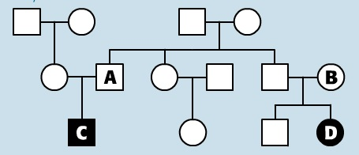
Individuals with PKU have blackened symbols.
What is the genotype of A?
a) Homozygous recessive
b) Homozygous dominant
c) Heterozygous

31. Nondisjunction:
a) leads to abnormal chromosome numbers.
b) generally occurs during mitosis
c) happens extremely rarely
d) all of the above

32. What is usually the source of cells used to diagnose chromosome abnormalities?
a) Maternal red blood cells.
b) Amniocentesis
c) Paternal sperm cells
d) Chorionic villus
e) A and B
f) B and C
g) B and D
h) A and C

33. Colchicine is a chemical substance that prevents the formation of microtubules. What stage of mitosis would be prevented, if dividing cells were treated with colchicines?
a) Breaking down of the nuclear membrane
b) Replication of DNA
c) Separation of genetically identical chromosomes (chromatids)
d) Supercoiling of chromosomes

34. Which of the following processes take place during interphase?
I. Respiration
II. Active transport
III. Protein synthesis
IV. Replication of DNA
a) I only b) I and II only c) I, II and III only d) I, II, III and IV

35. If a cell plate is beginning to form and nuclei are re-forming at opposite ends of a cell, what kind of cell is this?
a) An animal cell in prophase c) A plant cell in prophase
b) An animal cell in telophase d) A plant cell in telophase

36. Which statement is characteristic of tumours?
a) They occur only in certain animal cells.
b) They result from controlled cell division in only some organs.
c) They result from uncontrolled cell division and occur in any organ.
d) They result from partially controlled transcription.

