Name:_____________________________________________Date________________
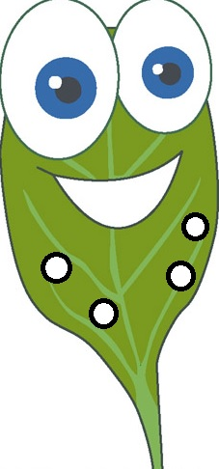

Question: Does the distance the light is from the spinach leaf discs affect how quickly the
discs rise due to photosynthesis?

Claim: Must be correct and complete (restate the question).
__________________________________________________________________________________________________________________________________________________________________________________________________________________________________________

Evidence: Provides appropriate and sufficient evidence to support the claim.
__________________________________________________________________________________________________________________________________________________________________________________________________________________________________________
__________________________________________________________________________________________________________________________________________________________________________________________________________________________________________
__________________________________________________________________________________________________________________________________________________________________________________________________________________________________________

Reasoning: Provides reasoning that links the evidence to the claim. Includes appropriate and sufficient scientific principles.
__________________________________________________________________________________________________________________________________________________________________________________________________________________________________________
__________________________________________________________________________________________________________________________________________________________________________________________________________________________________________
__________________________________________________________________________________________________________________________________________________________________________________________________________________________________________
__________________________________________________________________________________________________________________________________________________________________________________________________________________________________________
__________________________________________________________________________________________________________________________________________________________________________________________________________________________________________
__________________________________________________________________________________________________________________________________________________________________________________________________________________________________________

