Stem or Root? Monocot or Dicot? Xylem or Phloem? Label all you can
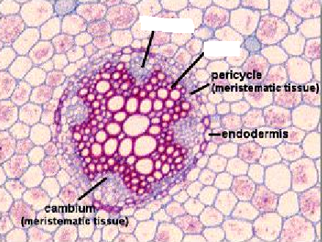 | 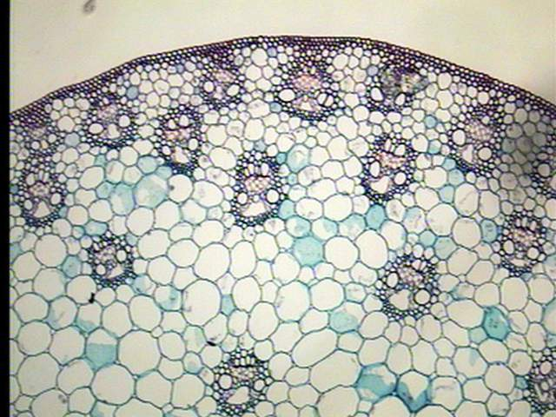
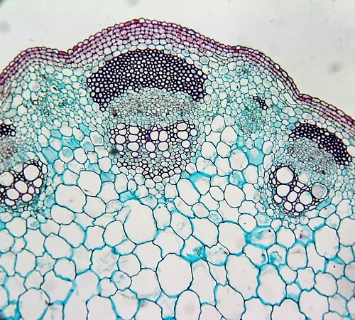 | 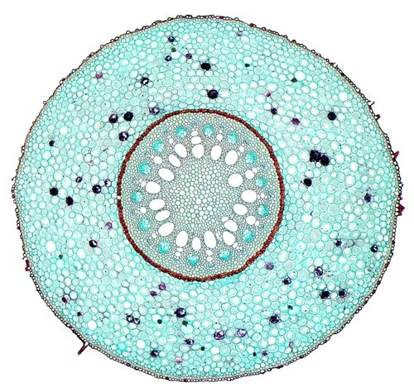

Below is a cross section of marram grass leaf. Can you find the vascular bundle? Xylem and Phloem?
Is this a monocot or dicot? What adaptations of xerophytes can you identify?
